IT’S BEAR SEASON!.LET’S TALK BEAR AWARENESS AND SAFETY!.
From back woods camping to walking trails, or fishing by the river, we are always in a location for a potential encounter with a foraging bear. Bears are out and about and doing what they do best besides sleep… and that’s Eat!. We often disregard their primal act of constant foraging in our outdoor planning as the bears scour the landscape to pack on all the weight possible in the summer season. In summer’s preparation to live dormant through another impending winter they source out any potential food prospect both natural and domestic. To make the most of the warm yet short outdoor season and we take off to the lakes, forests & trails often not thinking about the prospect of dealing with bears as a possibility let alone a priority. This is the feeding season for bears & happens to be the most active outdoor season for us humans too so the possibility of contact with bears is quite plausible indeed. We put our domestic trash in cans outside our houses that a bear can smell from miles away and we take food with us wherever we go and EVERYWHERE is bear territory. Let’s look at some options that we have available when we are facing an encounter with wildlife in the backyard or the outdoor arena. This information is also handy for dealing with wolf, coyote, cat’s & cougars or pretty much any animal out hunting for food. Any wildlife encounter with any predatory animal can pose a serious danger to us and you can’t always legally carry a firearm in many cases like on the local trails for example. It’s not legal, practical, feasible or even safe for us to do so. Add the concept of a firearm into a surprise or panic situation and then a firearm might not only be an ineffective option but it may prove to be just as dangerous or worse than the wildlife encounter itself!. SHOOTING SAFELY, QUICKLY & ACCURATLY IN A SUDDEN & MAXIUM STRESS SITUATION IS FAR MORE INEFFECTIVE AND DIFFICULT THAN YOU MAY THINK & IT MAY PUT YOU AND ANYONE AROUND YOU AT A GREATER RISK AND DANGER AS WELL!. The worst case scenario we often see in the field is that people to try to be prepared for an undesired wildlife encounter by having a firearm around the camp “just in case” and ironically it is usually “loaded”. The additional comment that usually follows is; “The gun is no use unloaded”. If the Firearm is going to be out of your hands at all it MUST NOT remain loaded. Furthermore it should only be loaded when the need & intent is to actually use it. A firearm sitting around loaded “just in case” is reckless and illegal. This applies to ammunition in an attached magazine. If you do NOT have the gun “in hand” and there is ammo in the mag you will get busted for that. Firearms charges are about the worst charges you can get stuck with. Consider anti gun police, judges, federal government and many other wacko liberal socialists and you have a legal disaster on your hands!. So let’s look at a safer, more proactive and less lethal option than live ammunition for both wildlife and ourselves.
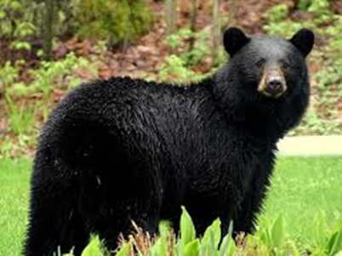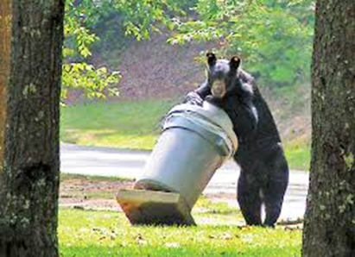

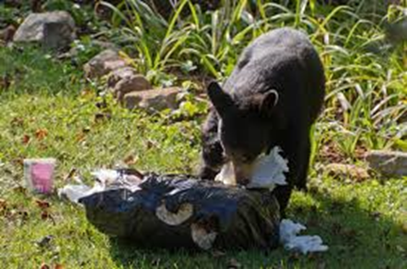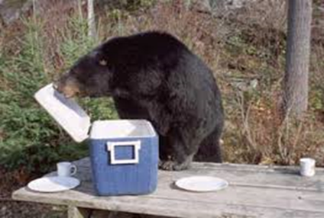

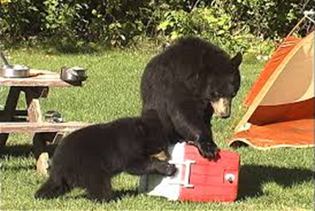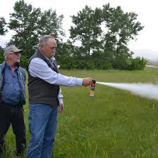

WHAT ABOUT BEAR SPRAY…..?. A non-lethal alternative.
Bear spray has proven very effective at repelling approaching or aggressive bears and reducing the incidence of human injury. In fact, it is even more effective than a firearm in preventing injury. Statistics show that people defending themselves with guns were injured about 50% of the time while people using bear spray usually escaped injury.
Bear spray is a special chemical solution containing 1%-2% capsaicin. This chemical comes from hot peppers; making the solution extremely irritating to the nose, eyes, throat, mouth and lungs. It temporarily disables the bear but causes no permanent harm.
Bear spray should be discharged only at approaching, charging or aggressive bears. Do not spray it on backpacks, clothing, tents or people; it is not a repellant like bug spray is. If you intend to carry bear spray make sure you read the manufacturer’s instructions closely and follow them. We also stock “Trueflare” easy carry pen style launchers which will launch emergency flares, bear bangers and we also carry 12 gauge shotgun bear bangers that can be fired from any 12 gauge shotgun as an alternative to “Live” ammunition. Please consider all these options and the multiple uses from the backpack, the ATV, boat for the out of town bush trips. Consider the bicycle or running shoes on the local trails?. Once again carrying a firearm while in remote locations is not illegal however not being in direct contact and control of a “loaded” firearm is illegal. As previously mentioned this includes having a clear chamber yet ammunition in the magazine. The firearm is considered loaded if it can launch any type / style of projectile that could possible cause death, any injury or property damage.
Actual live ammunition should only be used in extreme cases when there is: imminent danger to a person and when no alternative is possible, and when the live ammunition can be used in a manner that will not harm or injure anyone in the process.
Please consider all the available options and shoot straight and safe.
Thanks,
The firingline team.

